# Input Analysis

## 1. Rainfall Overview

**1.1 Average Annual Rainfall by Year**

SELECT crop_year, ROUND(AVG(annual_rainfall), 2) as AVG_rainfall

FROM crop_yield

GROUP BY CROP_Year

ORDER BY AVG_rainfall DESC;

**1.2 Min, Max & Average Rainfall by State**

SELECT

State,

MIN(Annual_Rainfall) AS Min_Rainfall,

MAX(Annual_Rainfall) AS MAX_Rainfall,

ROUND(AVG(Annual_Rainfall), 2) AS Avg_Rainfall

FROM

crop_yield

GROUP BY

State

ORDER BY

AVG_Rainfall DESC;

The State with the highest average annual rainfall was Meghalaya with 4043 and had quite varied rainfall with quite a difference between it’s minimum and maximum annual rainfall values.

## 2. Rainfall–Yield Relationships

**2.1 Rainfall, Yield Correlation by Crop**

SELECT

CROP,

CORR(Annual_Rainfall, Yield) AS Correlation

FROM Crop_Yield

GROUP BY CROP

ORDER BY Correlation DESC;

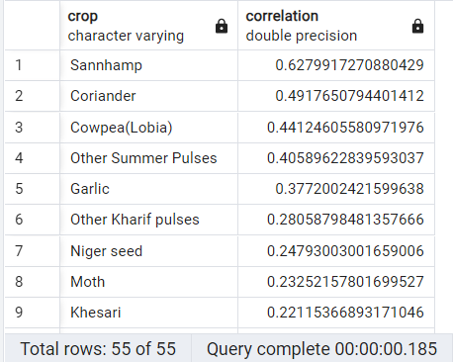

The crop with the greatest correlation between annual rainfall and yield is the Sannhamp crop.

## 3. Fertilizer & Pesticide Usage Patterns

**3.1 Fertilizer and Pesticide use by Season per Crop**

SELECT

Crop,

Season,

AVG(Fertilizer) AS AVG_Fertilizer,

AVG(Pesticide) AS AVG_Pesticide

FROM Crop_Yield

GROUP BY Crop, Season

HAVING Season NOT IN ('Whole Year')

ORDER BY Crop, Season;

**4.1 Fertilizer, Yield Correlation by Crop**

SELECT

CROP,

CORR(Fertilizer, Yield) as Correlation

FROM Crop_Yield

GROUP BY CROP

ORDER BY Correlation DESC;

**4.2 Pesticide, Yield Correlation by Crop**

SELECT

CROP,

CORR(Pesticide, Yield) AS Correlation

FROM Crop_Yield

GROUP BY CROP

ORDER BY Correlation DESC;

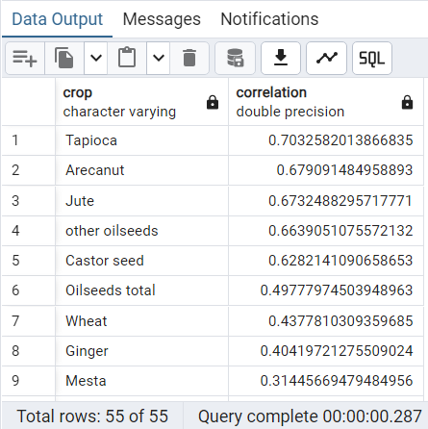

**4.3** **Fertilizer and Pesticide Correlation**

SELECT

corr(fertilizer, pesticide) as correlation_fert_pest

FROM crop_yield;

## 5. Scale & Efficiency Metrics

**5.1 Area Production by State and Year**

SELECT state,

crop_year,

SUM(area) as total_area,

SUM(production) as total_production

FROM crop_yield

GROUP BY state, crop_year

ORDER BY state, crop_year;

**5.2 Average Yield Per Area by Crop**

SELECT crop,

AVG(yield/area) as avg_yield_per_area

FROM crop_yield

GROUP BY crop

ORDER BY avg_yield_per_area DESC;

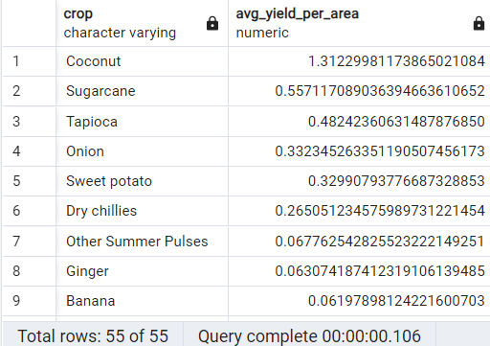

Coconuts lead in land-use efficiency